Understand Operators and Expressions

- Arithmetic, Relational and Logical Operators

Arithmetic Operators are used to perform arithmetic operations on numbers

let a = 3;
let x = (100 + 50) * a;

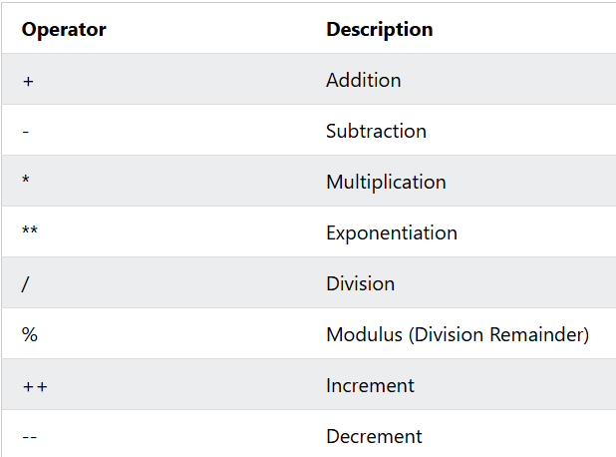

Relational Operators are used to compare two values
Relational Operators always return true or false

let x = 5;
let result = x > 8;

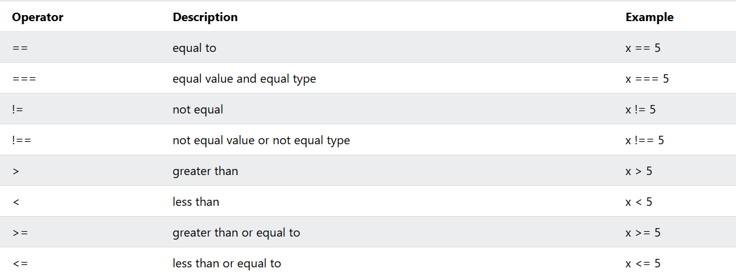

Logical Operator are used to determine the logic between variables or values

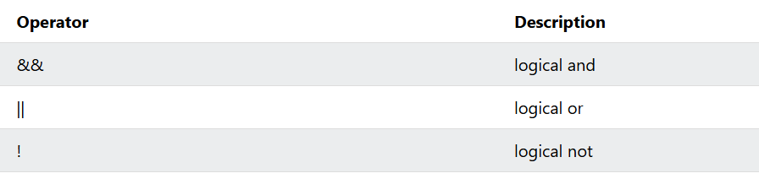

AND Operation

The && operator returns true if both expressions are true, otherwise false:

let x = 6;
let y = 3;
let z = (x < 10 && y > 1)

OR Operation

The || operator returns true if one or both expressions are true, otherwise false:

let x = 6;
let y = -3;
let z = (x > 0 || y > 0)

NOT Operation

The NOT operator (!) returns true for false expressions and false for true expressions.

let x = (5 == 8);
let y = !(5 == 8);

- Assignment Operators

Assignment Operator assigns values to the JavaScript variables

Given that x = 10 and y = 5, the table below explains the assignment operators:

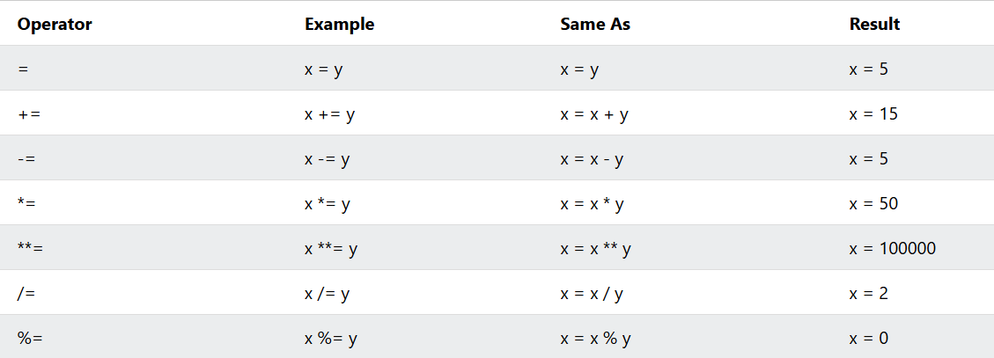

Logical Assignment Operators

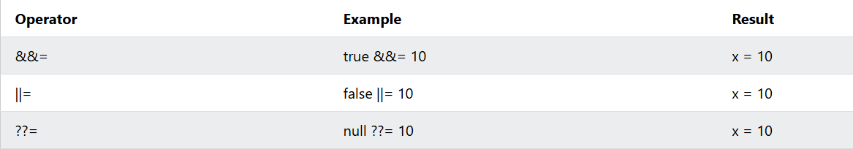

- Increment/Decrement

The increment operator (++) increments numbers.

let x = 5;
x++;
let z = x;

The decrement operator (--) decrements numbers.

let x = 5;
x--;
let z = x;

- Operator precedence and evaluation

Operator Precedence determines the priority in which operators are grouped and executed within an expression when multiple operators are present without explicit grouping parentheses.

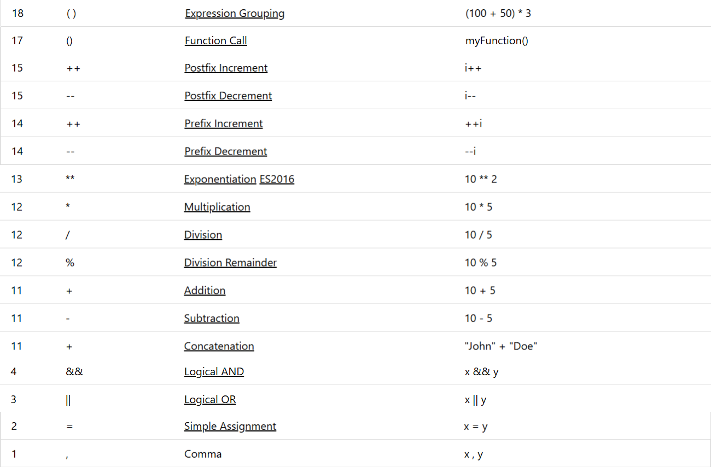

Operator Associativity

When two operators in an expression share the same precedence level, associativity defines the direction in which they are grouped for execution.

- Left-to-Right (LTR) Associativity: Most binary operators (e.g., +, -, *, /) group from left to right.

Example: 10 - 4 - 2 groups as (10 - 4) - 2 $→$ 4.

- Right-to-Left (RTL) Associativity: Assignment operators, exponentiation and unary operators from right to left.

Example (Exponentiation): 2 ** 3 ** 2 groups as 2 ** (3 ** 2) $→$ 512.
Example (Assignment): a = b = 5 groups as a = (b = 5).

Evaluation Order (Left-to-Right): JavaScript always evaluates operands and expressions strictly from Left to Right to fetch variable values or execute function calls before executing the operator math.
Precedence (Grouping): Precedence dictates how those fetched values are combined into the final result.

